SARS-CoV-2 in Gibraltar

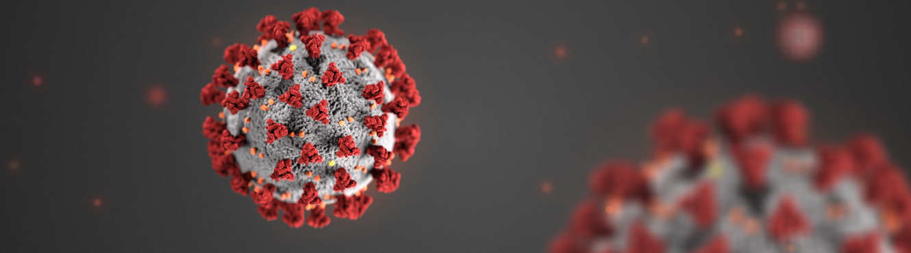

|  |  |
| --- | --- |
| Presented By: | Frank Lobe |

[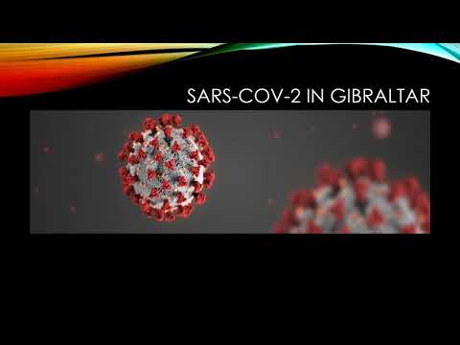](https://www.youtube.com/embed/uRrqKaHjcjA?feature=oembed)

Table of Contents

Introduction 1

The Goal 2

The Approach 3

Data Preparation Challenges 4

Conclusions 5

Appendix 8

Daily Tests 8

Results Pending 10

Active Cases 12

Infection Lifecycle Timeline **Error! Bookmark not defined.**

First Dose of Vaccine 16

Predictions Summary **Error! Bookmark not defined.**

Metric Correlations 18

Ratio Analysis 19

Ratio Observations **Error! Bookmark not defined.**

Vaccination Ratios 27



# Introduction

This presentation will examine SARS-CoV-2 (Covid-19) infection in Gibraltar. Gibraltar was selected for this presentation due to a very unique set of circumstances specific to the country.

* Gibraltar didn't have a death from covid-19 until November 11th, 2020.
* Gibraltar now has the highest death toll per capita in the world as of the time of this presentation. This death toll has happened in a short period of time.
* Gibraltar has been testing aggressively, with total tests several times that of the entire population.
* Gibraltar has been vaccinating aggressively since January 15th, 2021.
* Gibraltar has a median age that is very similar to the world median age.
* Gibraltar is a small country (6.8 square kilometres) with a low population (33,685) and high population density (~5000 per square kilometres) where transmission could occur very rapidly. It is possible that Gibraltar represents an accelerated timeline for what is happening everywhere else in the world.

This presentation will examine the possibility that Gibraltar is at or near a state of herd immunity for SARS-CoV-2.



# The Goal

The goal for this presentation is as follows;

* To quantify the true mortality rate for SARS-CoV-2.
* To quantify the impact of vaccinations.
* To provide a better understanding of the SARS-CoV-2 infection lifecycle from inception to completion.



# The Approach

Data was obtained directly from the government of Gibraltar which publishes SARS-CoV-2 infection and vaccination data daily on Twitter [1]. This is the same source data currently being published by worldometers.info [2].



# Data Preparation Challenges

The data published by the government of Gibraltar is very complete and of high quality. The main challenge in terms of data collection is that each day's data is published as a tweet in the form of an image file. Optical character recognition software and data scraping techniques were employed to transform this raw data into a more usable form.



# Conclusions

|  |  |
| --- | --- |
| Metric | Peak Date |
| Daily Change in Self-Isolation | 2020-12-19 |
| Results Pending | 2020-12-28 |
| Daily Change in Active Cases | 2020-12-30 |
| Daily Cases | 2021-01-04 |
| Self-Isolation | 2021-01-06 |
| Daily Tests | 2021-01-08 |
| Active Cases | 2021-01-08 |
| Daily Change in Recovered Cases | 2021-01-13 |
| Critical Care Occupancy | 2021-01-13 |
| Emergency Room Occupancy | 2021-01-15 |
| Deaths with COVID | 2021-01-17 |
| Deaths from COVID | 2021-01-18 |
| Total Deaths | 2021-01-18 |
| Daily Deaths from COVID | 2021-01-18 |
| Covid Ward Occupancy | 2021-01-22 |

Gibraltar has been testing aggressively during the entire period examined by this report. The regression function for total tests is virtually a straight line. This would suggest that Gibraltar was testing at full capacity during the period examined. This assertion is supported by the fact that pending tests increased significantly when infection rates began to spike.

Appendix: Daily Tests

Infection rates appear to have accelerated starting around the middle of December 2020. This is where the peak of self-isolating cases can be seen. Testing facilities appear to become overwhelmed around the end of December 2020. All plots would suggest that the growth and decline of infections were exponential in nature.

Appendix: Results Pending

Infection rates begin to go into decline around the third week of January. Average recovery time appears to be around twelve days. The worst period in terms of acceleration of deaths was the month of January.

The turning point appears to have been on or around January 8th, 2021. This date was used as the pivot point for regression models. On this date Gibraltar had a per capita death toll of 13 deaths per 10,000 in population.

The number of confirmed cases is unusual. First dose vaccinations didn't start until January 15th, 2021. Infections were already in decline at that point starting from around January 8th, 2021. Even those who were vaccinated starting on January 15th, 2021 wouldn't have received any benefit from it for some time. If the downturn in infections was the result of herd immunity starting to develop naturally in the population then the number of confirmed cases should be considerably higher considering how aggressively Gibraltar was testing. The alternative is that the mortality rate is much higher, and the results of this study do not support that conclusion. Another possible explanation is that the tests were returning a significant number of false negatives due to either the tests themselves or how the tests were being administered or processed. It is possible that a majority of the population had already acquired natural immunity prior to the introduction of widespread testing, but positive results even several weeks after infection is common. If this were the case then deaths probably would have began accelerating earlier. Another possibility is that confirmed cases were intentionally suppressed to accentuate the effectiveness of vaccinations and that most of those vaccinated had already acquire natural immunity.

Appendix: Active Cases

It would appear that five days is approximately the period of time where an infected individual either recovers from infection or requires critical care. Average time spent in critical care appears to be around nine days for patients that recovered and five days for those that subsequently died. Emergency room visits peaked after critical care, suggesting that individuals requiring critical care will progress to the point quicker than individuals with milder symptoms.

There doesn't appear to be any meaningful difference between individuals that died from COVID as opposed to individuals that died where COVID was an exasperating factor to a pre-existing condition. Therefore, only total deaths will be considered for further analysis. It should be noted that the ratio of those that died directly from COVID versus individuals that died with COVID was about seven to one.

The entire population of Gibraltar should have received a first dose by the middle of April, 2021 and second dose by the middle of May, 2021.

Appendix: First Dose of Vaccine

Emergency room, COVID ward and critical care occupancy are predicted to reach zero in the second or third week of March. Active cases are predicted to come reach zero at the end of March or beginning of April. Self-Isolating cases are predicted to reach zero at the end of April or beginning of May. A lag of about a week can be observed between emergency room occupancy and either COVID ward or critical care occupancy. Gibraltar appears to be enforcing a fairly lengthy self-isolation period. Self-isolation is expected to zero almost two months after the zero date of emergency room occupancy and about a month after active cases are expected to reach zero.

The greatest correlations exist between; daily cases, self-isolating cases, change in daily recovered cases, and active cases. The relationships between these metrics can be quantified with a predictability in low to mid 90% range.

Appendix: Metric Correlations

Infections begin to accelerate around the middle of December 2020 and begin to go into decline around the third week of January 2021. Recovery time appears to be about twelve days. The worst period in terms of acceleration of deaths was the month of January.

Appendix: Ratio Analysis

* Self-isolation was the first ratio to peak relative to active cases in the third week of December 2020.
* Testing capacity began to become overwhelmed in mid January 2021. This is also when self-isolation peaked relative to daily tests.
* Active tests peaked relative to daily tests in the third week of January.
* Emergency room visits peaked relative to daily tests at the end of January.
* The peak in recovery rates occurred at the beginning of February 2021, suggesting a recovery duration of about a week.
* COVID ward occupancy peaked relative to daily tests at the beginning of February 2021. This is also when emergency room occupancy peaked relative to self-isolation cases.
* Change in total deaths relative to daily tests occurred in the second week of February 2021. About two weeks after the peak in active cases, and a week after the peak in emergency room admittance. This is also when the peak in critical care relative to daily tests can be seen.
* The peak in daily deaths relative to self-isolating cases can be seen in mid February 2021.
* The peak in daily deaths relative to active and self-isolating cases can be seen at the end of February 2021.
* The peak in recovered cases relative to active cases can be seen in mid March 2021.

Appendix: Ratio Observations

Vaccinations appear to show a consistent exponential decline in vaccinations relative to; active cases, confirmed cases and total deaths. Confirming a decrease in outcomes given increasing vaccinations.

Appendix: Vaccination Ratios

Evidence would suggest that, given current SARS-CoV-2 variants and a median population age of 35, the mortality rate for SARS-CoV-2 is 28 deaths per 10,000 in population.

# Appendix

## Daily Tests

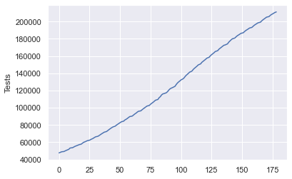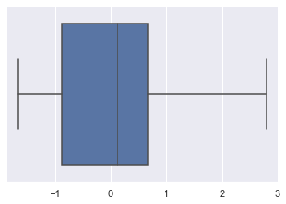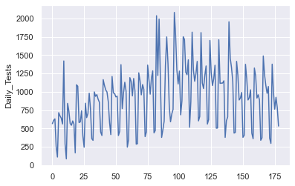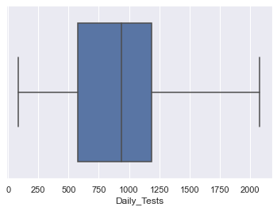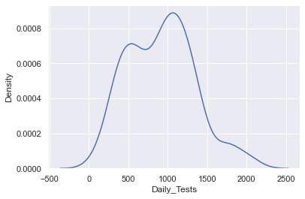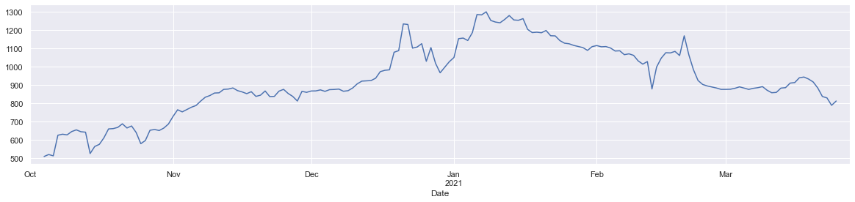

## Results Pending

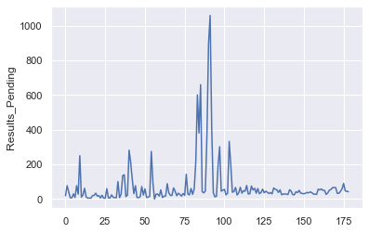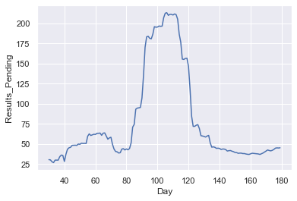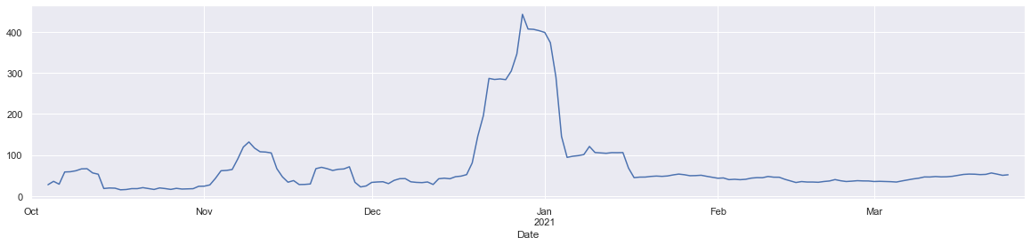

## Active Cases

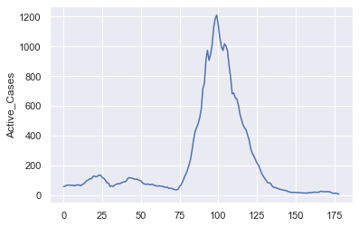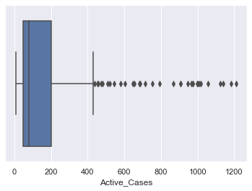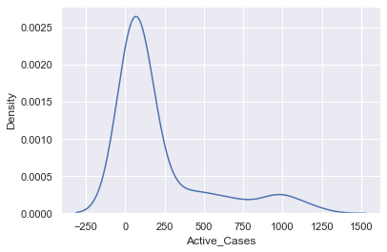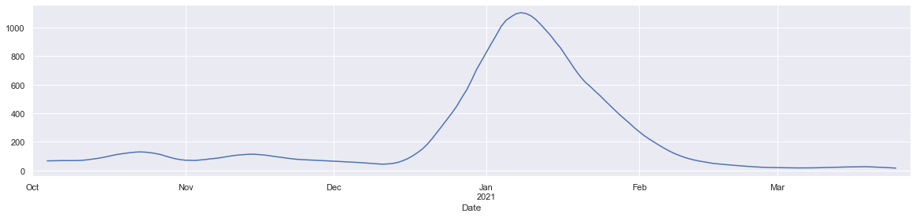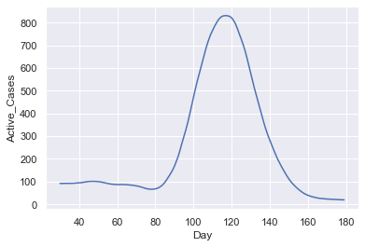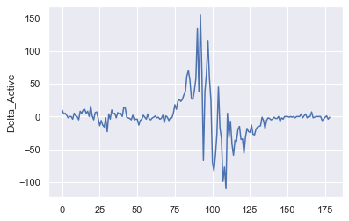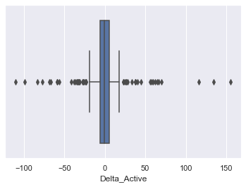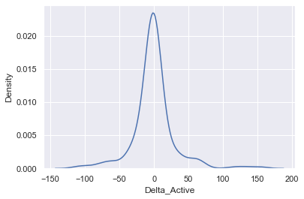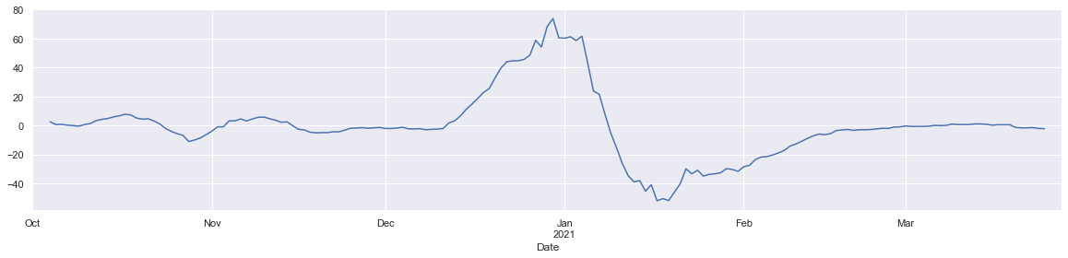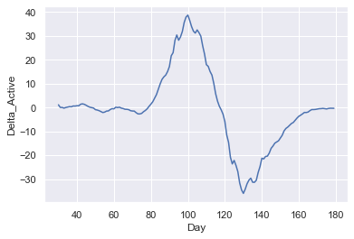

## First Dose of Vaccine

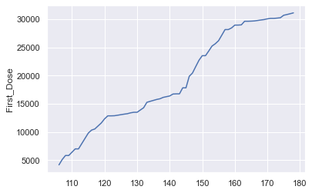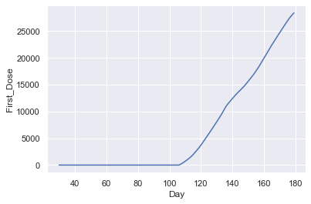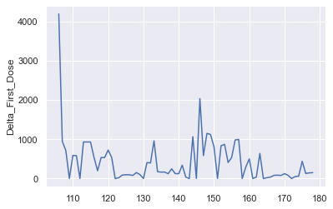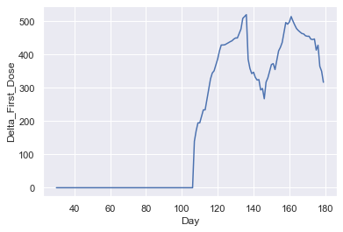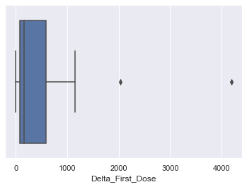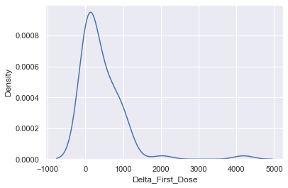

## Metric Correlations

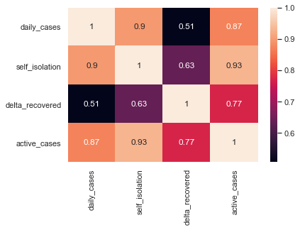

## Ratio Analysis

### Confirmed Cases to Tests

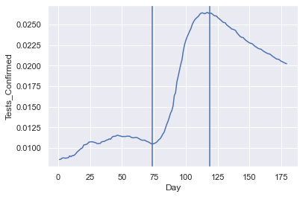

### Recovered Cases to Tests

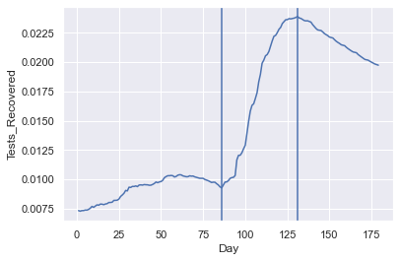

### Total Deaths to Tests

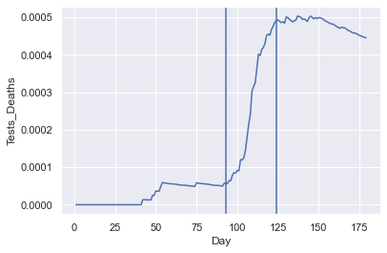

### Pending Results to Daily Tests

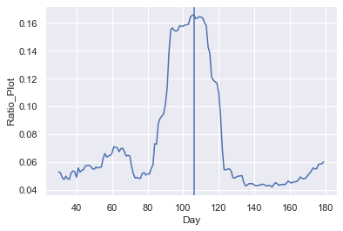

### Self-Isolation to Daily Tests

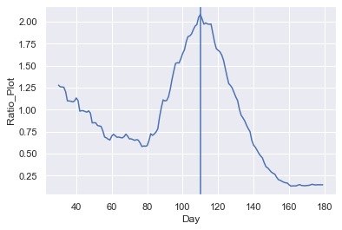

### Self-Isolation to Active Cases

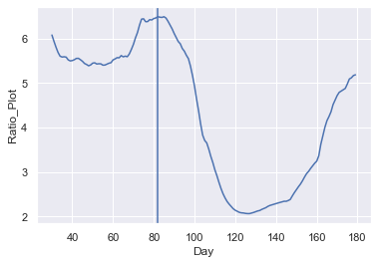

### Active Cases to Daily Tests

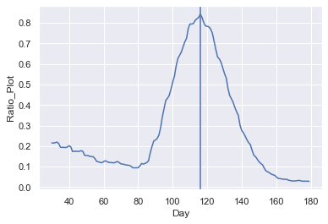

### Delta Recovered to Daily Tests

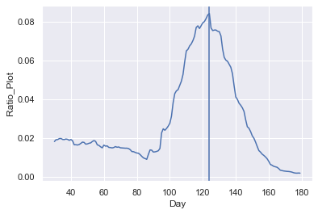

### Delta Recovered to Self-Isolation

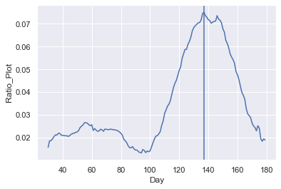

### COVID Ward to Daily Tests

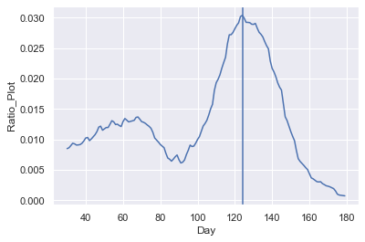

### Emergency Room to Daily Tests

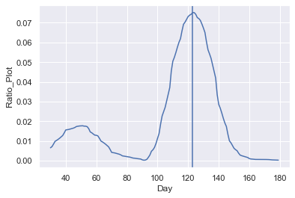

### Emergency Room to Self-Isolation

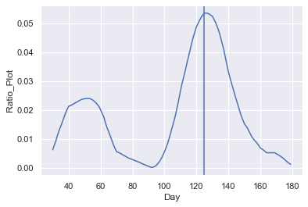

### Critical Care to Daily Tests

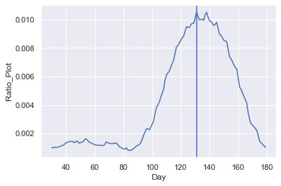

### Delta Total Deaths to Daily Tests

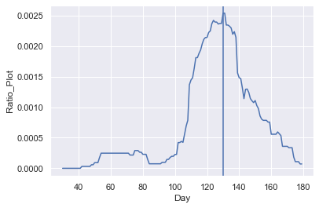

### Delta Total Deaths to Active Cases

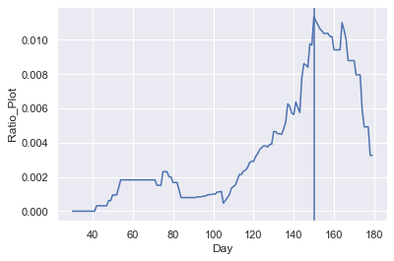

### Delta Total Deaths to Self-Isolation

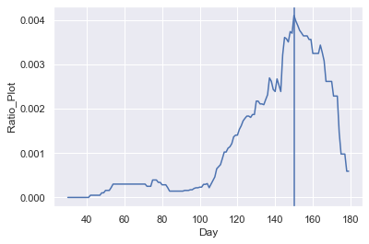

## Vaccination Ratios

### Active Cases to Vaccines Administered

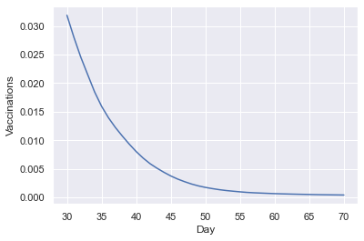

### Confirmed Cases to Vaccines Administered

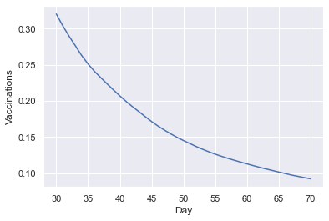

### Total Deaths to Vaccines Administered

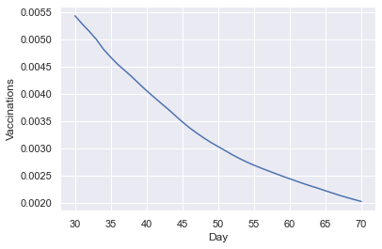

1. Government of Gibraltar Twitter Page, 2020 - 2021. [Online]. Available: <https://twitter.com/GibraltarGov/>
2. Worldometers Coronavirus - Gibraltar, 2020 - 2021. [Online]. Available: <https://www.worldometers.info/coronavirus/country/gibraltar/>